**Connect 4 Manual**

**Description**

This program allows the user to play ‘Connect4’, a popular game that has been played by millions. The game can either be run as a command-line game (playing the game within a command prompt) or the game can be played on a website viewed by a web browser. The assignment has been developed with version control by using GitHub and you can view our GitHub repository at: <https://github.com/faizan-mohiuddin/assignment3>.

**System Requirements**

* ‘Ruby’ installed on the machine/device that will be running the program.
* A Ruby gem (library) called ‘Sinatra’ needs to be installed as well.
* A web browser (preferably Google Chrome)
* An operating system: Windows 10, Windows 7 or other modern Windows operating systems. Other operating systems can be used but performance may vary.
* An internet connection. This is because the website takes the CSS (styling) from an external source through the internet called ‘Bootstrap’.

**Run Instructions**

1. Open the Windows command prompt and use the cd (change directory) command to navigate in to the “connect4” folder.

Example: cd *path*/connect4 (NB: replace *path* with your path to the connect4 folder)

1. Once you are in the connect4 folder, type “ruby wad_cf_run_01.rb”.
2. You will be prompted to either run the command-line based game or the web-based game.
3. If you selected the command-line based game, the game will run on the command prompt and you can enjoy playing the game. However, if you selected the web-based game, continue to step 5.
4. If you have selected the web-based game, wait a moment for the server to run and your command prompt should look something like this

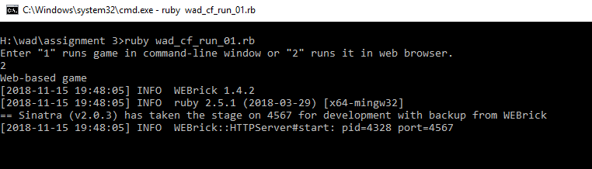

1. Once the server is running, open your web browser and type “localhost:4567” in to the address bar, enter, navigate to the ‘Play’ web page (using the navigation bar at the top of the web page) and enjoy playing the game.

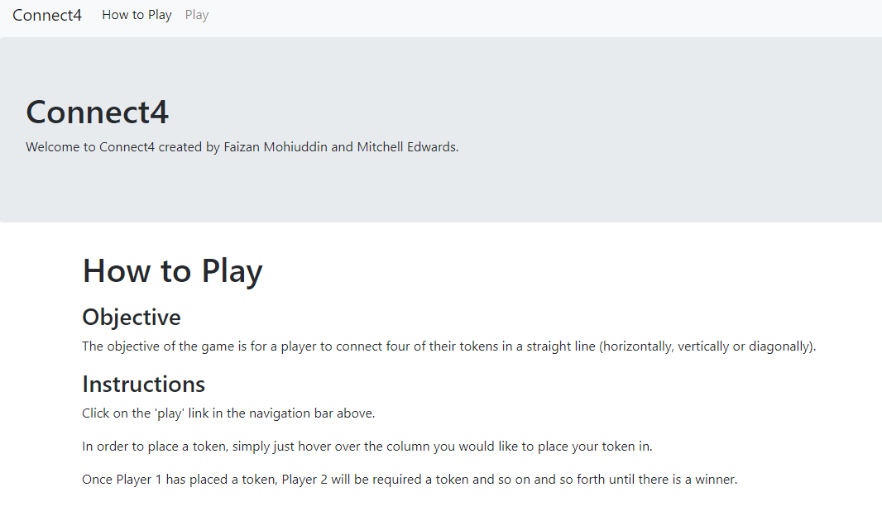

**Features and Functionalities**